

UDACITY DATA ANALYST NANODEGREE 2020

PROJECT

EXPLORING WEATHER TRENDS

Qasim Hassan

May 9th 2020

1. **INTRODUCTION:**

In this project, you will analyze local and global temperature data and compare the temperature trends where you live to overall global temperature trends.

The goal will be to create a visualization and prepare a write up describing the similarities and differences between global temperature trends and temperature trends in the closest big city to where you live. To do this, I’ll follow the steps below:

1. Extracting the Data
2. Open Downloaded CSV file
3. Create a line Chart
4. Observation
5. Conclusion
6. **EXTRACTING THE DATA:**

## SQL Query was used to download (CSV) file that contains yearly average temperature of all famous or big cities and global temperature of the world.

Then the data has been analyzed using Python Programming Language

using Jupyter Notebook i:e Explore_weather_trends.ipynb.

SQL Query was used to download two CSV Files that contain:

* 1. Data about global temperature such as (“year”, “Average) And has been imported by using the query underneath:



* 1. The closest city to my country that has information about the same data plus the name of the country and the City.



* 1. And has been imported by using the query underneath:

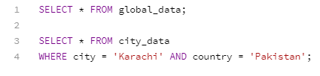

1. **MOVING AVERAGES:**
2. Rolling Average has been calculated to smooth out data and to make it easier to observe the trends when it be shown in Charts.
3. The Rolling Average has been calculated for every 10 years to each single data but the first 10!
4. Python was used for calculating the Moving Average Using Built-in Functions such as (“rolling”, “mean’).
5. Python Code for what has been explained:

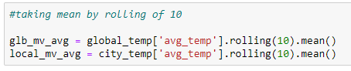

## **LINE CHART FOR THE DATA:**

## 

Two other charts for Global Temperature and Karachi city separately.

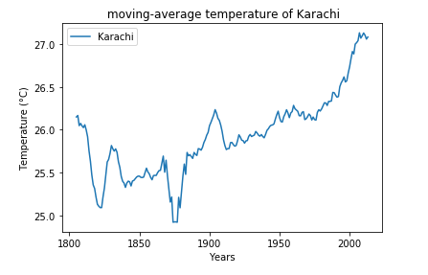

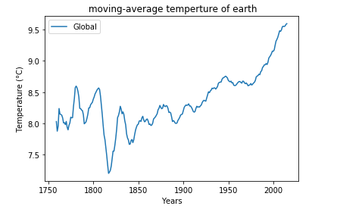

1. **OBSERVATIONS:**

i. By seeing the diagram, it shows that the temperature is ascending throughout the years because of environmental change.

ii. The Global temperature began to rise 'exponentially' since the center of 1800 which happened to be indistinguishable information from oil mining.

iii. Since 1975 the temperature is raising with no stops

iv. The contrast between the year 1800 and ~2010 in temperature is multiple degrees in the Global normal outline (expanding).

* The contrast between the year 1800 and ~2010 is multiple degrees in the Karachi City normal graph (expanding).
* Karachi city is getting sultrier after some time.
* The change of the climate between the globe and Karachi city is slightly small now but it was much differing from each other in the beginning, and both of them are raising.

## **CONCLUSION:**

There is an evidence suggests that the global temperature is raising over the years which support the case of climate change.